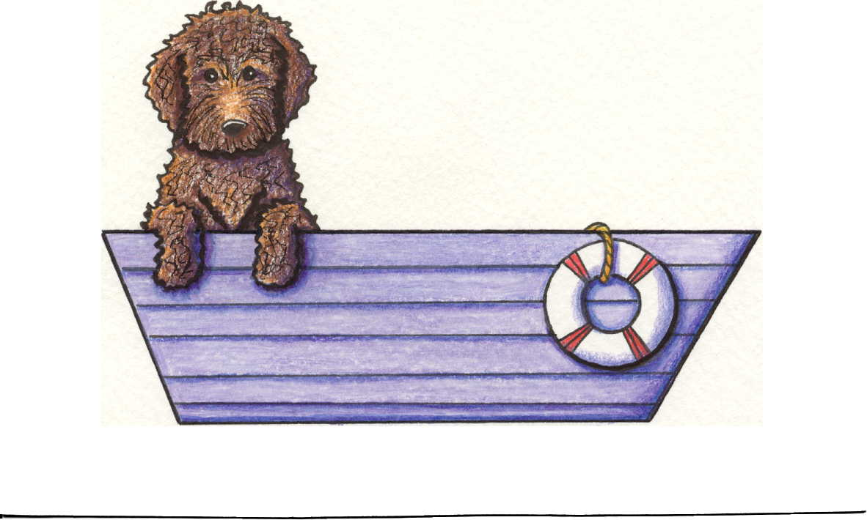
Puppy Information
Snug Harbor
Labradoodles

Snug Harbor Labradoodles would like to thank you for your interest in our puppies, and are happy to provide this information packet to you. If you have any questions please don’t hesitate to contact us. The cost of Snug Harbor puppies is $2800 plus tax and any shipping costs, regardless of color or gender.

Adoption of a Snug Harbor Australian Labradoodle:
We register applications on a first come first served basis secured by a non-refundable, deductable $350.00 booking fee. You may either email your application or send it via US mail with your deposit to the address below.

Snug Harbor accepts 4-6 pet deposits per litter and reserves the right to retain a puppy for breeding.

You will be notified when you application in accepted and again when your puppy is born

Adoption of a Snug Harbor Labradoodle includes the following:
      - All puppies will be spayed/neutered prior to leaving for their new homes.
      - Copies of all veterinary records for care received prior to placement
      - Micro-chip: To assist in identification of the puppy should he/she ever be lost
      - Copy of pedigree and our two year Health guarantee
      - Lifetime of support for you and your dog
      - Food and educational information on dog foods and dietary requirements

Additionally, we expect the owner of a Snug Harbor Labradoodle puppy:
- To have realistic expectations of what it means to be a dog owner
- To accept responsibility for the dogs well being.
- To understand that this responsibility includes ongoing expense and veterinary care.
- To have puppy seen by a veterinarian within 72 hours of receiving him/her

Breeders of Australian Labradoodles

